|  |  |
| --- | --- |
|  | **Journal of Emerging Educational Studies**  **JEES** |

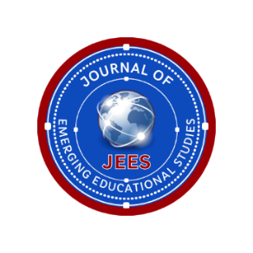

**Title of the Manuscript**

**Author 1**

|  |  |
| --- | --- |
| **Title:** |  |
| **Name Surname:** |  |
| **University, Department:** |  |
| **City, Country:** |  |
| **e-mail Address:** |  |
| **Phone Number:** |  |
| **ORCID:** |  |

**Author 2**

|  |  |
| --- | --- |
| **Title:** |  |
| **Name Surname:** |  |
| **University, Department:** |  |
| **City, Country:** |  |
| **e-mail Address:** |  |
| **Phone Number:** |  |
| **ORCID:** |  |

**Author 3**

|  |  |
| --- | --- |
| **Title:** |  |
| **Name Surname:** |  |
| **University, Department:** |  |
| **City, Country:** |  |
| **e-mail Address:** |  |
| **Phone Number:** |  |
| **ORCID:** |  |

**Notes:**

Please specify the corresponding authors by putting an asteriks after the author number (e.g. Author 5*).

All authors should provide a valid ORCID number.